Electrical Safety Advice.

The Myth of “Safety Socket Covers”
The Estates department are advising all staff that socket covers must not be used on the premises, and all departments should contact Estates, to dispose of them. Staff should also reconsider their usage in the domestic environment.

Children cannot poke things into British sockets - they have built in automatic shutters for protection.
A baby's finger is not small enough to go into the socket holes far enough to reach the live parts, but to make sure there are insulated shutters on the inside of the holes which prevent anything but a plug being inserted. These shutters close automatically as soon as the plug is pulled out.
UK law requires all sockets sold to conform to the BS 1363 standard, ensuring your child's safety. Sockets are made to accept plugs which meet very exact requirements (and the law requires that plugs are certified as meeting the requirements). Nothing failing to meet those requirements should ever be put in a socket, there are no socket covers which meet those requirements
A myth invented by socket cover suppliers is that children can easily put their fingers into unprotected sockets!
No socket covers have been approved for use in UK BS 1363 sockets.
- No socket covers are available which meet the correct dimensions for plugs!
- Anything made to the wrong dimensions may cause permanent damage.
- Socket covers introduce a variety of dangers; they make sockets less safe, not more.
- Some socket covers have many faults, some just a few, but none makes your sockets safer.
Socket Covers should NOT be inserted into sockets - they are dangerous
Unlike real plugs, the various design faults of socket covers allow a curious child to insert them (upside down) into the earth pin only. On many sockets this opens the safety shutters and allows children access to the live contacts!
Normally it is quite difficult to find an object which will do that, and stay in place.
The left hand socket below shows the holes are covered by insulated shutters, preventing objects other than a plug being inserted. The other socket shows what happens when a child plugs an upside down cover into the earth hole. It can be clearly seen that this has operated the shutter system and exposed the live contacts.

Plug-in Socket Covers Are Dangerous!
The so-called “safety socket cover” usually takes the form of a dummy 13A plug, but real plugs must be made to a very precise size, and sockets are made to fit them. Putting the wrong size and shape object into a socket causes a number of problems, including permanent socket damage:
- Socket contact damage -results in overheating and possible fire
- Socket shutter damage - the shutters will not be able to protect children
- Some socket covers make it possible to poke pins and paper clips into the live parts!
- Broken plastic pins stuck in the earth hole - prevents shutters from closing
- Wrong size pins can make covers easy to remove, some even pop out by themselves!
Children like to play with socket covers - plugging in upside down opens the shutter and exposes live contacts
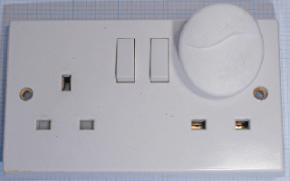 | 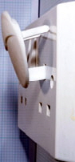
Shutters are open and live!

