Control of Substances Hazardous to Health |  | HEALTH & SAFETY  PROCESS BASED COSHH ASSESSMENT |  |  | 
Reference: | COSHH RA1 |  | Date: | July 2015
Overall Risk Rating = LOW
A low risk rating has been assigned to this process because the control measures in place and the results of occupational hygiene monitoring indicate that personal exposure to hazardous substances in use is below any Workplace Exposure Limit and as such the risk is considered to be low.

Process Description
Hazardous Substances in use/contained within the material(s) in use:
Commercial name(s):
Principal Supplier:
Is the substance mixed with any other substance?
What is the new substance
Are SDS available?
Work Practice Information - Examples
Preparation
- The Paint system is prepared for either spraying rolling or brushing purposes by mixing the additive which is solvent based to the base material which contains epoxy resins and other pigments in a solvent based media.
- Mixing is carried out in a ventilated room.
Spraying
- If the material is to be sprayed then the spray guns are charged with the appropriate amount of paint that is required for the job in hand.
- Spraying is carried out in a ventilated spray booth.
- Operators carrying out the spraying activity wear respiratory protective equipment in the form of full air fed face masks coveralls and gloves.
- After spraying is completed spray guns are emptied of surplus paint and washed in a specific gun washing cabinet.
Hand brushing
- The paint system is applied to the work piece by brush within a ventilated booth.
- Operators carrying out this activity wear coveralls and gloves.
- On completion of the task brushes are cleaned in a specific washing cabinet.
Rolling
- The paint system is applied to the work piece by roller within a ventilated booth.
- Operators carrying out this activity wear coveralls and gloves.
- On completion of the task brushes are cleaned in a specific washing cabinet.

Approximate Material Usage Information |  |  |  |  |  | Production dependant but up to 5 litres per day.
Who may be exposed to the hazardous substance(s) |  |  |  |  |  | Operators carrying out the task.
Approximate exposure to the identified hazardous substances during the working day?

 |  | <1/2 hour |  |  | ½ - 2 hours |  |  | 2 – 4 hours
X |  | 4 – 8 hours |  |  | Over 8 hours |  |  | All day

Where are the materials used? (Please indicate below)

 |  | Outside | X |  | Inside - well ventilated |  |  | Inside - poorly ventilated
 |  | Confined space | X |  | Others - Please Specify | Spray booth with local exhaust ventilation

Associated Risk Phrases:Examples
R10 |  | Flammable |  |  |  |  |  |  | R20/21 |  |  |  | Harmful by Inhalation and contact with skin
R22 |  | Harmful if swallowed |  |  |  |  |  |  | R36/37 /38 |  |  |  | Irritating to skin respiratory system and eyes
R41 |  | May cause serious damage to eyes
Hazard Signage
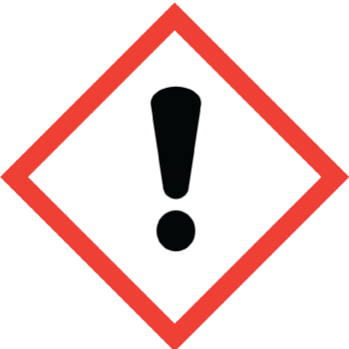 |  |  |  | 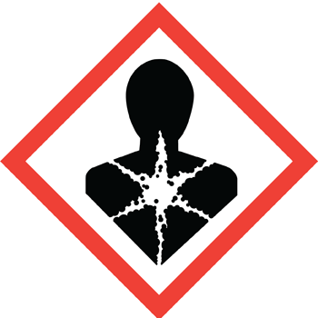 |  |  |  |  |  |  | 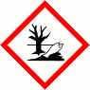 |  |  |  |  | 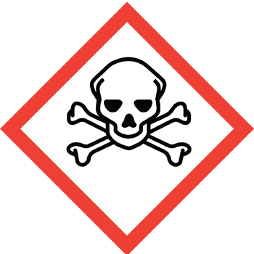
Potential routes of exposure: Examples |  |  |  |  | Inhalation, skin and eye contact.
Potential Consequences of exposure: |  |  |  |  | Inhalation of the vapours generated can lead to long term lung function damage, in the short term shortage of breath and dizziness may occur. Long term exposure to solvents may result in neurological damage.  Skin contact may result in itchiness and redness; long term skin contact may result in sensitisation to the product or its constituents. Persons with a history of skin sensitisation problems should only be employed in processes in which this product is used under appropriate medical supervision.  Eye contact may result in redness and irritation of the eye.  Injection skin penetration by sharps  Ingestion eating / swallowing.
Hierarchy of Control Measures - Examples
Can the hazardous substance(s) be substituted or eliminated? |  |  |  |  | No the use of the material is essential to the requirements of the company’s products in ensuring a suitable final finish is achieved.
Existing Engineering Control Measures: |  |  |  |  | Enclosed spray booth with local exhaust ventilation extraction.
Total or partial enclosure, general ventilation, local exhaust ventilation, dilute, reduce employees, reduce time limits, housekeeping. Training, first aid kit, welfare, medical records, health surveillance, PPE, supervision.
Personal Protective Equipment - Examples
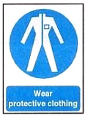 | Tyvek Disposable overalls |  |  |  |  |  |  |  |  | 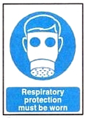 |  | Air-fed respiratory protective equipment
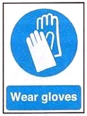 | Chemically-resistant disposable gloves – Ansel “Solvex” nitrile gloves, alternatively gloves manufactured from “Viton” |  |  |  |  |  |  |  |  | 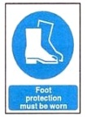 |  | Safety Shoes/boots
Other Control measures |  |  |  |  | Safe systems of work for the activities being carried out.  Time served painters/sprayers. Air-fed respiratory protective equipment – checked daily.
Maintenance Activities |  |  |  |  | The cleaning of brush’s rollers and spray guns is covered in a separate assessment.
Workplace Exposure Limits (WEL) taken from EH40/2005 – where available
Substance |  |  |  |  |  |  | WEL 8hr TWA mg/m³ |  |  |  |  |  |  | STEL 15min TWA mg/m³
Ethyl benzene |  |  |  |  |  |  | 441 |  |  |  |  |  |  | 552
2-methylpropan-1-ol |  |  |  |  |  |  | 154 |  |  |  |  |  |  | 231
Xylene (mixture of isomers) |  |  |  |  |  |  | 220 |  |  |  |  |  |  | 441
Air Monitoring and Health Surveillance
Air Monitoring information: |  |  |  |  | No air monitoring has been carried out when these paint systems have been in use. But there close similarity to other brands of paint containing similar constituents implies that the following data is likely to provide a suitable and sufficient estimate of potential exposure.  Xylene = 6 – 12% of the WEL  Trimethylbenzene = 9 – 18% of the WEL  1-methoxypropan-2-ol = 1% of the WEL  Other Volatile Organic Compounds = 1 – 4% of the WEL
Health Surveillance information: |  |  |  |  | Respiratory Surveillance – annually  Skin surveillance - annually
Additional measures required:
Date of Review |  |  |  |  |  |  |  | Reviewed by:
Additional measures required following review

