Fire Action Notice
On discovering a fire –
Contact the Fire and Rescue Service Immediately
Tel: 999
Stating the address and postcode:
 | Only attempt to fight the fire if it is safe to do so, and you are competent and you have a safe evacuation route.
 | Do not use water on electrical or flammable liquid fires.
On hearing the fire alarm –
Leave the caravan by the nearest and safest available exit.
Where possible CLOSE all doors as you leave.
DO NOT stop to collect personal belongings.
DO NOT re-enter the caravan until instructed to do so.
Ensure all occupants leave the building with you.
Go immediately to the designated assembly point
The assembly point is at:

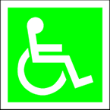 | Disabled people should be assisted along the evacuation route.
SCFAN

